Lancaster Parks & Recreation “Everyone Plays” Soccer
Rules of Competition/Laws of the Game Modifications

Definitions
- Preschool - Ages 4 years & under
- Division 1 - Ages 6 years old & under
- Division 2 - Ages 8 years old & under
- Division 3 - Ages 10 years old & under
- Division 4 - Ages 12 years old & under
- Division 5 - Ages 14 years old & under

Law 1 - The Field of Play
Small sided Fields - All fields are laid out & lined by Parks Department staff.
- Division 3 will be using the “Build-out” lines.
- All Divisions will have bench/technical areas and spectator “stay back” lines. The purpose of these is to keep the players and game officials safe & enforce the correct areas where teams & spectators are required to be.

Law 2 - The Ball
- Ball is provided by the “Home Team”, must be in good condition: no rips, tears, or open seams.
  - Preschool: Size 3
  - Division 1: Size 3
  - Division 2: Size 3
  - Division 3: Size 4
  - Division 4: Size 4
  - Division 5: Size 5

Law 3 - The Number of Players
- Preschool: 4 v 4 players, NO goalkeeper
- Division 1: 4 v 4 players, NO goalkeeper
- Division 2: 4 v 4 players, NO goalkeeper
- Division 3: 7 v 7 players, one of whom is the designated goalkeeper. A match may not start or continue if either team has less than five (5) players.
- Division 4: 9 v 9 players, one of whom is the designated goalkeeper. A match may not start or continue if either team has less than six (6) players.
- Division 5: Ideally, 11 v 11 players, one of whom is the designated goalkeeper. A match may not start if either team has less than nine (9) players, or continue if either team has less than seven (7) players.
  - However, depending on enrollment/roster sizes, this division may play 9 v 9, and a match can not begin, or continue, with less than seven (7) players.
- Teams will play with the same number of players on the field, regardless of age, unless there is a player that has been sent off (red carded/ejected).
- Substitutions: Unlimited, HOWEVER in order to keep the game moving & give the players the most time to play, the following restrictions will be used: kickoff, goal kick, own team throw in, or either throw in if both teams want to sub. MUST have players ready at center line BEFORE the ball is out of play.
- Goalkeepers: A “designated goalkeeper” is required to wear an outer shirt/jersey/pinnie which clearly identifies them as the goalkeeper, and is a different color than both of the teams playing. The Referees will determine if the goalkeeper needs to change to a different color. The Parks Department is not responsible for, and will not provide, goalkeeper shirts/pinnies.
Law 4 - Players Equipment
Shinguards are MANDATORY, and MUST be covered entirely by socks.
Shoes: No metal baseball cleats. Flat tennis shoes are acceptable.
Absolutely no jewelry. This includes fitness trackers, and earrings. IT IS NOT PERMITTED FOR EARRINGS TO BE COVERED WITH TAPE, BANDAGES, ETC.
Exception is medical alert bracelet, and those those must be taped down. Prescription eyeglasses are permitted. Sports safety prescription glasses are encouraged. Absolutely NO sunglasses, except for Rx Sun.
Often with colder weather, players may want to wear hooded sweatshirts. As long as the team jersey is on the outside/top, this in itself is not a problem, HOWEVER in the interest of player safety, the hood MUST be tucked in. This is required to eliminate a potential choking hazard. Players may also wear soft sided hats (knit hats, beanies, etc) to keep warm as well. No hats with a hard, fixed bill will be permitted, this includes baseball caps for any players.

Law 5 - The Referee
- Each match is controlled by referees who has full authority to enforce the Laws of the Game in connection with the match.
- Decisions will be made to the best of the referee's ability according to the Laws of the Game and the ‘spirit of the game’ and will be based on the opinion of the referee, who has the discretion to take appropriate action within the framework of the Laws of the Game.
- The decisions of the referee regarding facts connected with play, including whether or not a goal is scored and the result of the match, are final. The decisions of the referee, and all other match officials, must always be respected.
- Additionally, referees are representatives of the Parks Office, and if an individual is asked to leave the Soccer Complex, that individual is expected to do so promptly.
- Powers & Duties
The referee:
- enforces the Laws of the Game
- controls the match in cooperation with the other match officials
- acts as timekeeper, keeps a record of the match and provides the appropriate authorities with a match report, including information on disciplinary action and any other incidents that occurred before, during or after the match
- supervises and/or indicates the restart of play
- has the authority to take disciplinary action from entering the field of play for the pre-match inspection until leaving the field of play after the match ends. If, before entering the field of play at the start of the match, a player commits a sending-off offense, the referee has the authority to prevent the player taking part in the match; the referee will report any other misconduct
- has the power to show yellow or red cards from entering the field of play at the start of the match until after the match has ended
- takes action against team officials who fail to act in a responsible manner and warns or shows a yellow card for a caution or a red card for a sending-off from the field of play and its immediate surrounds (“out of sight, out of sound”), including the technical area; if the offender cannot be identified, the senior coach present in the technical area will receive the sanction.
- Referee Equipment
  - Referees must have the following equipment:
- Whistle(s)
- Watch(es)
- Red and yellow cards
- Notebook (or other means of keeping a record of the match)

Law 7 - Duration of the Match
- Preschool: Two (2) equal halves of fourteen (14) minutes, of four (4) seven (7) minute quarters
- Division 1: Two (2) equal halves of sixteen (16) minutes, or four (4) eight (8) minute quarters
- Division 2: Two (2) equal halves of twenty (20) minutes, or four (4) ten (10) minute quarters
- Division 3: Two (2) equal halves of twenty-five (25) minutes
- Division 4: Two (2) equal halves of thirty (30) minutes
- Division 5: Two (2) equal halves of thirty (30) minutes

Law 8 - The Start and Restart of Play
1. KICK-OFF
Procedure
- the team that wins the toss of a coin decides which goal to attack in the first half or to take the kick-off
- depending on the above, their opponents take the kick-off or decide which goal to attack in the first half
- the team that decided which goal to attack in the first half takes the kick-off to start the second half
- for the second half, the teams change ends and attack the opposite goals
- after a team scores a goal, the kick-off is taken by their opponents
For every kick-off:
- all players, except the player taking the kick-off, must be in their own half of the field of play
- the opponents of the team taking the kick-off must be at least:
  - Division 3: eight (8) yards from the ball until it is in play.
  - Division 4: eight (8) yards from the ball until it is in play.
  - Division 5: ten (10) yards from the ball until it is in play.
- the ball must be stationary on the centre mark
- the referee gives a signal
- the ball is in play when it is kicked and clearly moves
- a goal may be scored directly against the opponents from the kick-off; if the ball directly enters the kicker’s goal, a corner kick is awarded to the opponents
  - EXCEPTION: Preschool, Divisions 1 & 2 MAY NOT score a goal directly from a kick-off, the ball must be played by another player.
Offenses and sanctions
- If the player taking the kick-off touches the ball again before it has touched another player, an indirect free kick is awarded.
- In the event of any other kick-off procedure offense, the kick-off is retaken.

Law 9 - The Ball In and Out of Play
The ball is out of play when:
- it has wholly passed over the goal line or touchline on the ground or in the air
- play has been stopped by the referee
- it touches a match official, remains on the field of play and:
  - a team starts a promising attack or
  - the ball goes directly into the goal or
  - the team in possession of the ball changes
In all these cases, play is restarted with a dropped ball.
The ball is in play at all other times when it touches a match official and when it rebounds off a goalpost, crossbar or corner flagpost and remains on the field of play.

Law 10 - Determining the Outcome of a Match
A goal is scored when the whole of the ball passes over the goal line, between the goalposts and under the crossbar, provided that no offense has been committed by the team scoring the goal.
If the goalkeeper throws the ball directly into the opponents’ goal, a goal kick is awarded.
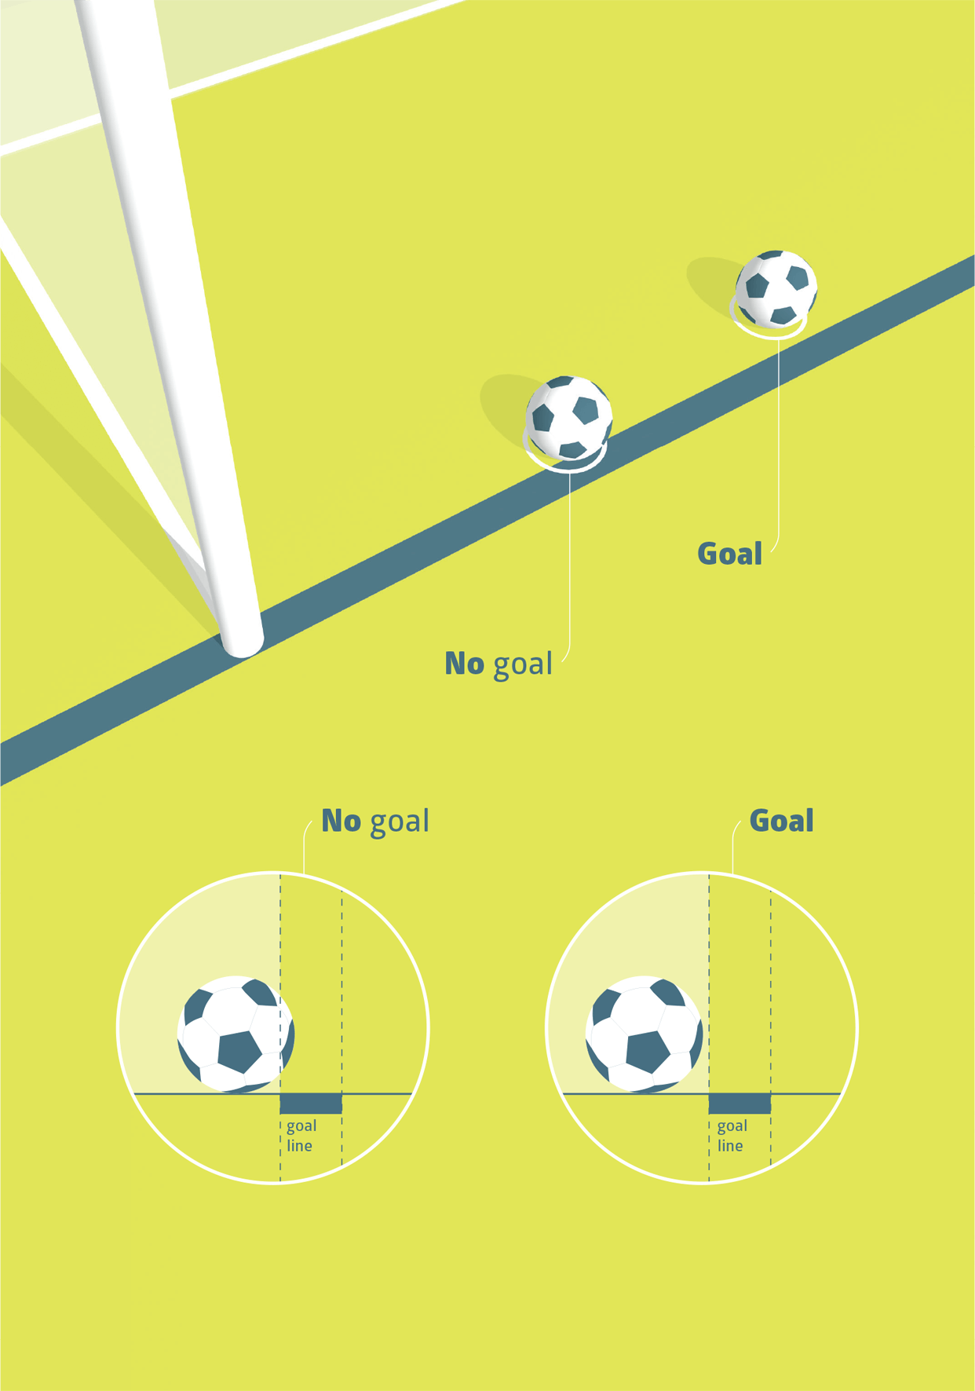

Law 11 - Offside
- Division 5: Conform to FIFA Laws of the Game
- Division 4: Conform to FIFA Laws of the Game
- Division 3: Attacking players are in an offside position only when they are in their opponent’s Build-Out-Area.
  - The Build-Out-Lines are used as the offside lines, therefore no offside offense can occur between the two Build-Out-Lines.

Law 12 - Fouls & Misconduct
- Division 5: Conform to FIFA Laws of the Game; Heading is allowed without limitations
- Division 4: Conform to FIFA Laws of the Game; Heading is allowed without limitations
- Division 3: Conform to FIFA Laws of the Game with the exception that an indirect free kick is awarded to the opposing team at the spot of the offense if a goalkeeper punts or drop-kicks the ball. If the punt occurs within the goal area, the indirect free kick should be taken on the goal area line parallel to the goal line at the nearest point to where the infringement occurred.
  - When a player deliberately heads the ball in a game, an indirect free kick should be awarded to the opposing team from the spot of the offense. If the deliberate header occurs within the goal area, the indirect free kick should be taken on the goal area line parallel to the goal line at the nearest point to where the infringement occurred.
  - Free kick (IFK or DFK) restarts from within a team’s own Build-Out-Area, the opponents must:
  - 1) move and remain at least 8-yds. from the ball until it has been put back into play
  - 2) move and remain outside the penalty area AND be at least 8-yds. from the ball until it has been put back into play for free kicks from within the penalty area
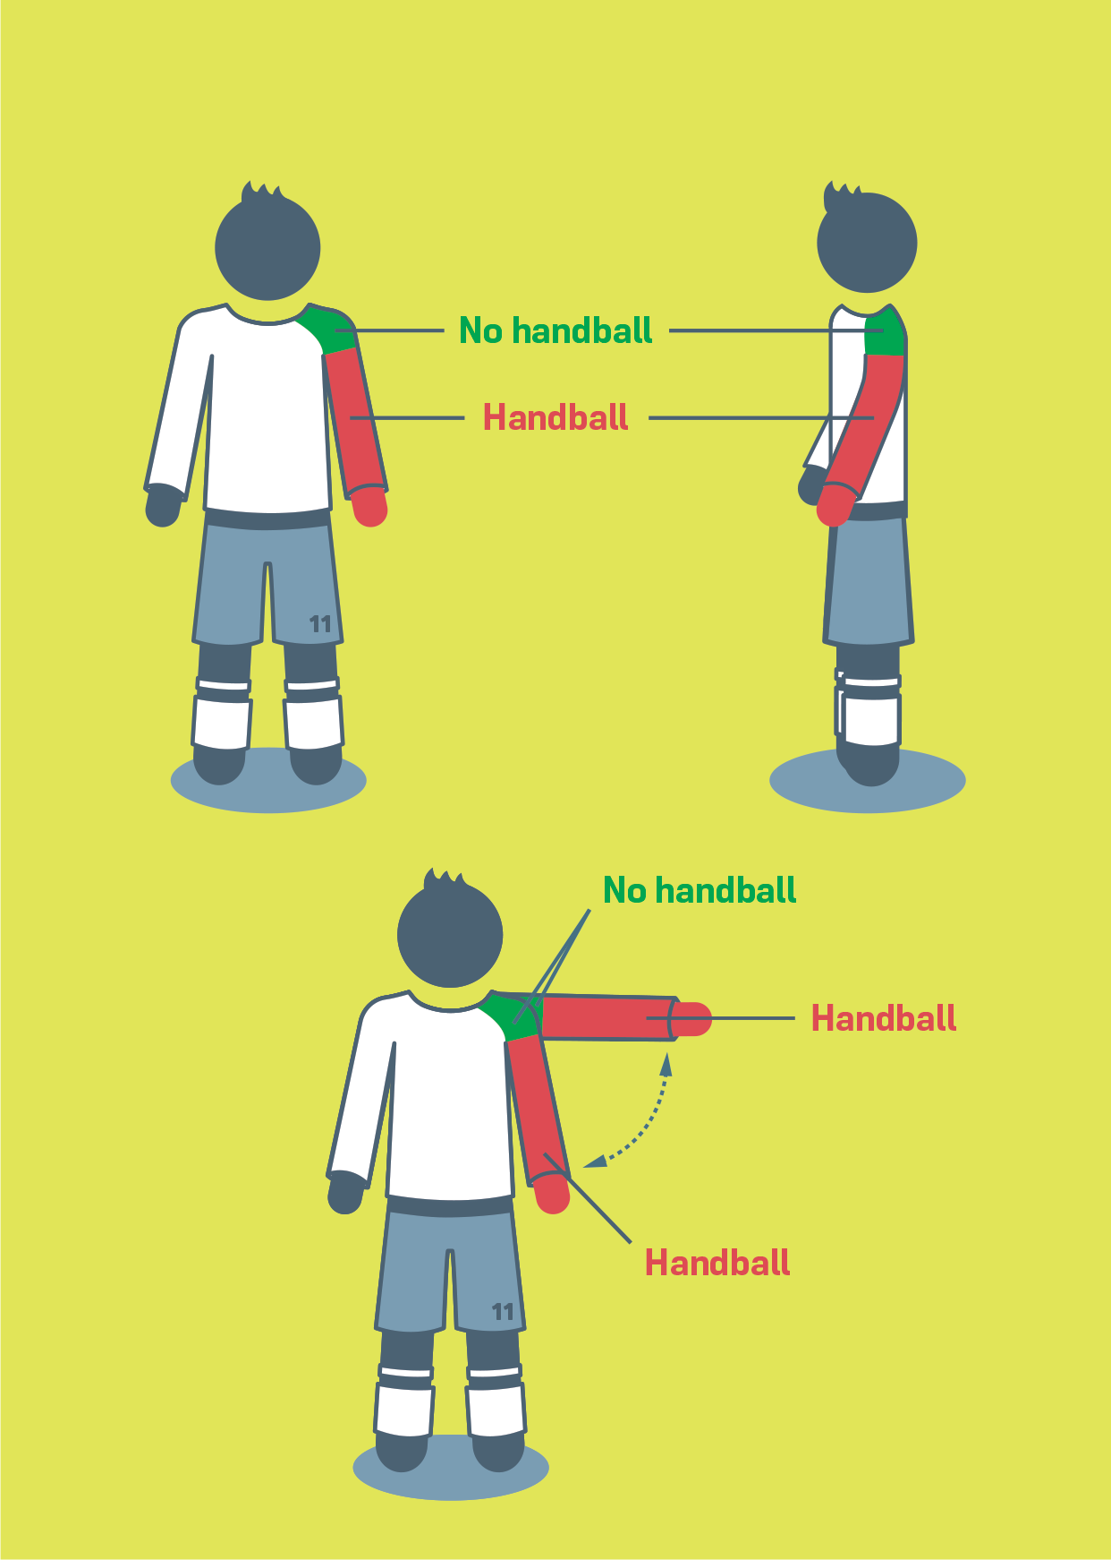
  - All Divisions: There is NO slide-tackling. If slide tackle occurs, an indirect free kick is awarded to the opposing team at the spot, if no other more serious foul occurs as a result.

Cautionable offenses
A player is cautioned if guilty of:
- delaying the restart of play
- dissent by word or action
- entering, re-entering or deliberately leaving the field of play without the referee’s permission
- failing to respect the required distance when play is restarted with a corner kick, free kick or throw-in
- persistent offenses (no specific number or pattern of offenses constitutes 'persistent')
- unsporting behavior
Where two separate cautionable offenses are committed (even in close proximity), they should result in two cautions, for example if a player enters the field of play without the required permission and commits a reckless tackle or stops a promising attack with a foul/handball, etc.

Cautions for unsporting behavior
There are different circumstances when a player must be cautioned for unsporting behavior including if a player:
- attempts to deceive the referee, e.g. by feigning injury or pretending to have been fouled (simulation)
- changes places with the goalkeeper during play or without the referee’s permission (see Law 3)
- commits in a reckless manner a direct free kick offense
- handles the ball to interfere with or stop a promising attack
- commits a foul which interferes with or stops a promising attack, except where the referee awards a penalty kick for an offense which was an attempt to play the ball
- denies an opponent an obvious goal-scoring opportunity by an offense which was an attempt to play the ball and the referee awards a penalty kick
- handles the ball in an attempt to score a goal (whether or not the attempt is successful) or in an unsuccessful attempt to prevent a goal
- shows a lack of respect for the game
- uses a deliberate trick to pass the ball (including from a free kick) to the goalkeeper with the head, chest, knee etc. to circumvent the Law, whether or not the goalkeeper touches the ball with the hands
- verbally distracts an opponent during play or at a restart
Sending-off offenses
A player, substitute or substituted player who commits any of the following offenses is sent off:
- denying the opposing team a goal or an obvious goal-scoring opportunity by a handball offense (except a goalkeeper within their penalty area)
- denying a goal or an obvious goal-scoring opportunity to an opponent whose overall movement is towards the offender’s goal by an offense punishable by a free kick (unless as outlined below)
- serious foul play
- biting or spitting at someone
- violent conduct
- using offensive, insulting or abusive language and/or gestures
- receiving a second caution in the same match
A player, substitute or substituted player who has been sent off must leave the vicinity of the field of play and the technical area.
Denying a goal or an obvious goal-scoring opportunity
Where a player denies the opposing team a goal or an obvious goal-scoring opportunity by a handball offense, the player is sent off wherever the offense occurs.
Where a player commits an offense against an opponent within their own penalty area which denies an opponent an obvious goal-scoring opportunity and the referee awards a penalty kick, the offender is cautioned if the offense was an attempt to play the ball; in all other circumstances (e.g. holding, pulling, pushing, no possibility to play the ball etc.) the offending player must be sent off.
A player, sent-off player, substitute or substituted player who enters the field of play without the required referee’s permission and interferes with play or an opponent and denies the opposing team a goal or an obvious goal-scoring opportunity is guilty of a sending-off offense.
The following must be considered:
- distance between the offense and the goal
- general direction of the play
- likelihood of keeping or gaining control of the ball
- location and number of defenders
Serious foul play
A tackle or challenge that endangers the safety of an opponent or uses excessive force or brutality must be sanctioned as serious foul play.
Any player who lunges at an opponent in challenging for the ball from the front, from the side or from behind using one or both legs, with excessive force or endangers the safety of an opponent is guilty of serious foul play.
Violent conduct
Violent conduct is when a player uses or attempts to use excessive force or brutality against an opponent when not challenging for the ball, or against a team-mate, team official, match official, spectator or any other person, regardless of whether contact is made.
In addition, a player who, when not challenging for the ball, deliberately strikes an opponent or any other person on the head or face with the hand or arm, is guilty of violent conduct unless the force used was negligible.
TEAM OFFICIALS
Where an offense is committed and the offender cannot be identified, the senior team coach present in the technical area will receive the sanction.
Warning
The following offenses should usually result in a warning; repeated or blatant offenses should result in a caution or sending-off:
- entering the field of play in a respectful/non-confrontational manner
- failing to cooperate with a match official e.g. ignoring an instruction/request from an assistant referee or the fourth official
- minor/low-level disagreement (by word or action) with a decision
- occasionally leaving the confines of the technical area without committing another offense
Caution
Caution offenses include (but are not limited to):
- clearly/persistently not respecting the confines of their team’s technical area
- delaying the restart of play by their team
- deliberately entering the technical area of the opposing team (non-confrontational)
- dissent by word or action including:
  - throwing/kicking drinks bottles or other objects
  - gestures which show a clear lack of respect for the match official(s) e.g. sarcastic clapping
- excessively/persistently gesturing for a red or yellow card
- gesturing or acting in a provocative or inflammatory manner
- persistent unacceptable behavior (including repeated warning offenses)
- showing a lack of respect for the game
Sending-off
Sending-off offense include (but are not limited to):
- delaying the restart of play by the opposing team e.g. holding onto the ball, kicking the ball away, obstructing the movement of a player
- deliberately leaving the technical area to:
  - show dissent towards, or remonstrate with, a match official
  - act in a provocative or inflammatory manner
- enter the opposing technical area in an aggressive or confrontational manner
- deliberately throwing/kicking an object onto the field of play
- entering the field of play to:
  - confront a match official (including at half-time and full-time)
  - interfere with play, an opposing player or a match official
- physical or aggressive behavior (including spitting or biting) towards an opposing player, substitute, team official, match official, spectator or any other person (e.g. ball boy/girl, security or competition official etc.)
- receiving a second caution in the same match
- using offensive, insulting or abusive language and/or gestures
- violent conduct

Law 13 - Free Kicks
1. TYPES OF FREE KICK
Direct and indirect free kicks are awarded to the opposing team of a player, substitute, substituted or sent-off player, or team official guilty of an offense.
Indirect free kick signal
The referee indicates an indirect free kick by raising the arm above the head; this signal is maintained until the kick has been taken and the ball touches another player, goes out of play or it is clear that a goal cannot be scored directly.
An indirect free kick must be retaken if the referee fails to signal that the kick is indirect and the ball is kicked directly into the goal.
- Divisions 3 & 4: All opponents are at least eight (8) yards from the ball until it is in play.
- Division 5: All opponents are at lease ten (10) yards from the ball until it is in play.
2. PROCEDURE
All free kicks are taken from the place where the offense occurred, with some exceptions
The ball:
- Must be stationary and the kicker must not touch the ball again until it has touched another player
- is in play when it is kicked and clearly moves

Law 14 - The Penalty Kick
- Divisions 3 & 4: Conform to FIFA/IFAB Laws of the Game
  - The penalty mark is ten (10) yards from the goal line.
- Division 5: Conform to FIFA/IFAB Laws of the Game.
  - The penalty mark is twelve (12) yards from the goal line.

Law 15 - The Throw-in
A goal cannot be scored directly from a throw-in:
- if the ball enters the opponents’ goal – a goal kick is awarded
- if the ball enters the thrower’s goal – a corner kick is awarded
1. PROCEDURE
At the moment of delivering the ball, the thrower must:
- stand facing the field of play
- have part of each foot on the touchline or on the ground outside the touchline
- throw the ball with both hands from behind and over the head from the point where it left the field of play
- All opponents must stand at least 2 m (2 yds) from the point on the touchline where the throw-in is to be taken.
- The ball is in play when it enters the field of play. If the ball touches the ground before entering, the throw-in is retaken by the same team from the same position. If the throw-in is not taken correctly, it is retaken by the opposing team.
  - Divisions 1 & 2: Allow for same team to retake the throw-in. Try to “help” the player perform the throw-in correctly
- The thrower must not touch the ball again until it has touched another player.
2. OFFENSES AND SANCTIONS
If, after the ball is in play, the thrower touches the ball again before it has touched another player, an indirect free kick is awarded; if the thrower commits a handball offense:
- a direct free kick is awarded
- a penalty kick is awarded if the offense occurred inside the thrower’s penalty area unless the ball was handled by the defending team’s goalkeeper, in which case an indirect free kick is awarded
An opponent who unfairly distracts or impedes the thrower (including moving closer than 2 m (2 yds) to the place where the throw-in is to be taken) is cautioned for unsporting behavior, and if the throw-in has been taken, an indirect free kick is awarded.

Law 16 - The Goal Kick
- Division 3: Opposing players must move and remain outside the Build-Out-Area until the ball is in play.
  - The ball is in play when it is kicked and clearly moves.
- Division 4: Conform to FIFA/IFAB Laws of the Game.
- Division 5: Conform for FIFA/IFAB Laws of the Game

Law 17 - The Corner Kick
Conform to FIFA/IFAB Laws of the Game

Addendum:
The “Everyone Plays” Soccer League is a recreational league. The purpose of the League is to allow the young players a chance to play, learn, and enjoy the game of soccer. Coaches are expected to comport themselves in a respectful manner at all times, as they are role models for their players. This includes being examples of, and teaching their players, good sportsmanship. Coaches are also responsible for the behavior of the spectators supporting their team(s). In that regard, coaches may be asked by referees to address any unacceptable behavior from their spectators.

http://www.theifab.com/laws
Updated by ZK, 11/27/23; Approved by JS, 11/28/23

